Given a zero-based permutation nums (0-indexed), build an array ans of the same length where ans[i] = nums[nums[i]] for each 0 <= i < nums.length and return it.
A zero-based permutation nums is an array of distinct integers from 0 to nums.length - 1 (inclusive).

Example 1:
Input: nums = [0,2,1,5,3,4]
Output: [0,1,2,4,5,3]
Explanation: The array ans is built as follows:
ans = [nums[nums[0]], nums[nums[1]], nums[nums[2]], nums[nums[3]], nums[nums[4]], nums[nums[5]]]
= [nums[0], nums[2], nums[1], nums[5], nums[3], nums[4]]
= [0,1,2,4,5,3]
Example 2:
Input: nums = [5,0,1,2,3,4]
Output: [4,5,0,1,2,3]
Explanation: The array ans is built as follows:
ans = [nums[nums[0]], nums[nums[1]], nums[nums[2]], nums[nums[3]], nums[nums[4]], nums[nums[5]]]
= [nums[5], nums[0], nums[1], nums[2], nums[3], nums[4]]
= [4,5,0,1,2,3]

Constraints:
- 1 <= nums.length <= 1000
- 0 <= nums[i] < nums.length
- The elements in nums are distinct.

Program:
class Solution {
public int[] buildArray(int[] nums) {
int[] temp = new int[nums.length];
for (int i = 0; i < nums.length; i++)
temp[i] = nums[nums[i]];
return temp;
}
}
Output:

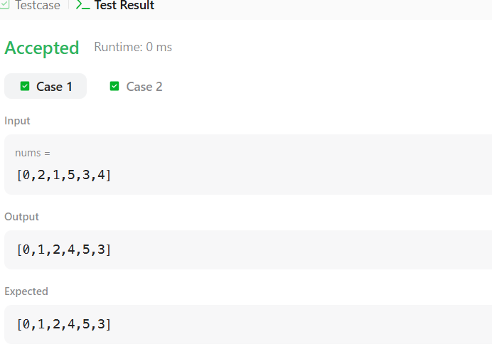

Given the array nums consisting of 2n elements in the form [x₁,x₂,...,x_{n},y₁,y₂,...,y_{n}].
Return the array in the form [x₁,y₁,x₂,y₂,...,x_{n},y_{n}].

Example 1:
Input: nums = [2,5,1,3,4,7], n = 3
Output: [2,3,5,4,1,7]
Explanation: Since x₁=2, x₂=5, x₃=1, y₁=3, y₂=4, y₃=7 then the answer is [2,3,5,4,1,7].
Example 2:
Input: nums = [1,2,3,4,4,3,2,1], n = 4
Output: [1,4,2,3,3,2,4,1]
Example 3:
Input: nums = [1,1,2,2], n = 2
Output: [1,2,1,2]

Constraints:
- 1 <= n <= 500
- nums.length == 2n
- 1 <= nums[i] <= 10^3
Program:
class Solution {
public int[] shuffle(int[] nums, int n) {
int len = nums.length;
int[] ans = new int[len];
for (int i = 0; i < len; i++) {
if (i % 2 == 0) {
// Even positions get elements from the first half
ans[i] = nums[i / 2];
} else {
// Odd positions get elements from the second half (starting at index n)
ans[i] = nums[n + (i / 2)];
}
}
return ans;
}
}
Output:
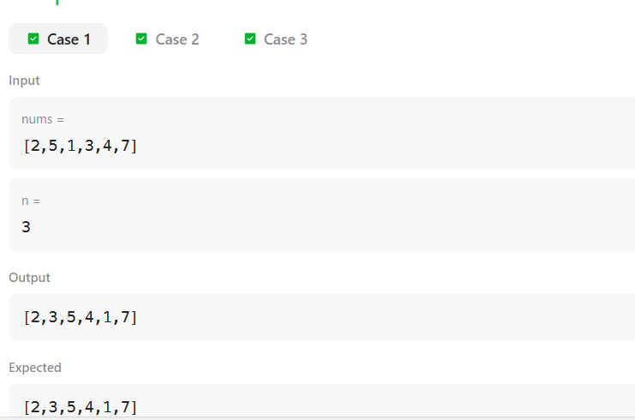

Given an integer array nums and an integer val, remove all occurrences of val in nums in-place. The order of the elements may be changed. Then return the number of elements in nums which are not equal to val.
Consider the number of elements in nums which are not equal to val be k, to get accepted, you need to do the following things:
- Change the array nums such that the first k elements of nums contain the elements which are not equal to val. The remaining elements of nums are not important as well as the size of nums.
- Return k.
Custom Judge:
The judge will test your solution with the following code:
int[] nums = [...]; // Input array
int val = ...; // Value to remove
int[] expectedNums = [...]; // The expected answer with correct length.
// It is sorted with no values equaling val.

int k = removeElement(nums, val); // Calls your implementation

assert k == expectedNums.length;
sort(nums, 0, k); // Sort the first k elements of nums
for (int i = 0; i < actualLength; i++) {
assert nums[i] == expectedNums[i];
}
If all assertions pass, then your solution will be accepted.

Example 1:
Input: nums = [3,2,2,3], val = 3
Output: 2, nums = [2,2,_,_]
Explanation: Your function should return k = 2, with the first two elements of nums being 2.
It does not matter what you leave beyond the returned k (hence they are underscores).
Example 2:
Input: nums = [0,1,2,2,3,0,4,2], val = 2
Output: 5, nums = [0,1,4,0,3,_,_,_]
Explanation: Your function should return k = 5, with the first five elements of nums containing 0, 0, 1, 3, and 4.
Note that the five elements can be returned in any order.
It does not matter what you leave beyond the returned k (hence they are underscores).

Constraints:
- 0 <= nums.length <= 100
- 0 <= nums[i] <= 50
- 0 <= val <= 100
Program:

class Solution {
public int removeElement(int[] nums, int val) {
int index = 0;
for (int i = 0; i < nums.length; i++) {
if (nums[i] != val) {
nums[index] = nums[i];
index++;
}
}
return index;
}
}
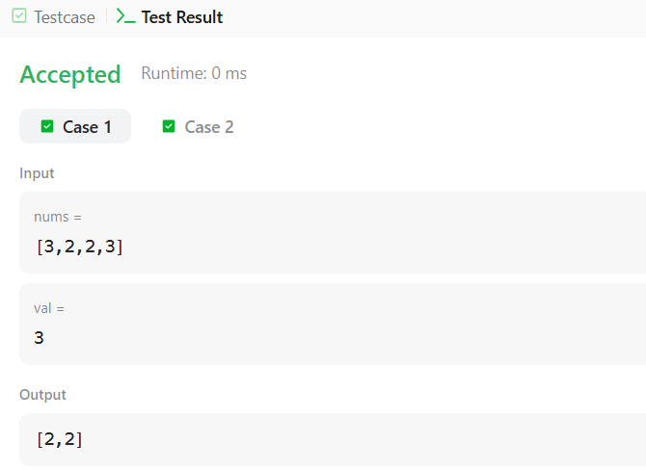
Given an integer array nums sorted in non-decreasing order, remove the duplicates in-place such that each unique element appears only once. The relative order of the elements should be kept the same.
Consider the number of unique elements in nums to be k​​​​​​​​​​​​​​. After removing duplicates, return the number of unique elements k.
The first k elements of nums should contain the unique numbers in sorted order. The remaining elements beyond index k - 1 can be ignored.
Custom Judge:
The judge will test your solution with the following code:
int[] nums = [...]; // Input array
int[] expectedNums = [...]; // The expected answer with correct length

int k = removeDuplicates(nums); // Calls your implementation

assert k == expectedNums.length;
for (int i = 0; i < k; i++) {
assert nums[i] == expectedNums[i];
}
If all assertions pass, then your solution will be accepted.

Example 1:
Input: nums = [1,1,2]
Output: 2, nums = [1,2,_]
Explanation: Your function should return k = 2, with the first two elements of nums being 1 and 2 respectively.
It does not matter what you leave beyond the returned k (hence they are underscores).
Example 2:
Input: nums = [0,0,1,1,1,2,2,3,3,4]
Output: 5, nums = [0,1,2,3,4,_,_,_,_,_]
Explanation: Your function should return k = 5, with the first five elements of nums being 0, 1, 2, 3, and 4 respectively.
It does not matter what you leave beyond the returned k (hence they are underscores).

Constraints:
- 1 <= nums.length <= 3 * 10⁴
- -100 <= nums[i] <= 100
- nums is sorted in non-decreasing order.

Program:
class Solution {
public int removeDuplicates(int[] nums) {
if (nums.length == 0) return 0;

int i = 1;

for (int j = 1; j < nums.length; j++) {
if (nums[j] != nums[i - 1]) {
nums[i] = nums[j];
i++;
}
}

return i;
}
}

Output:
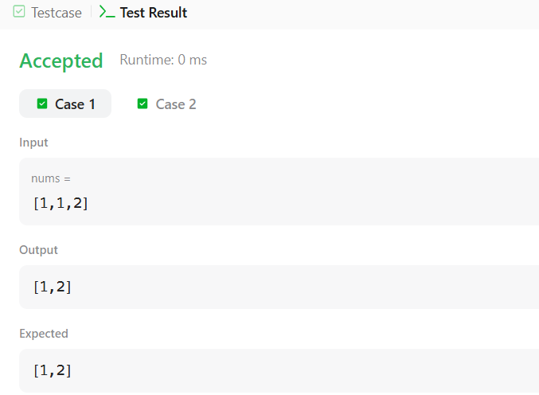

Given an integer array nums, find the subarray with the largest sum, and return its sum.

Example 1:
Input: nums = [-2,1,-3,4,-1,2,1,-5,4]
Output: 6
Explanation: The subarray [4,-1,2,1] has the largest sum 6.
Example 2:
Input: nums = [1]
Output: 1
Explanation: The subarray [1] has the largest sum 1.
Example 3:
Input: nums = [5,4,-1,7,8]
Output: 23
Explanation: The subarray [5,4,-1,7,8] has the largest sum 23.

Constraints:
- 1 <= nums.length <= 10⁵
- -10⁴ <= nums[i] <= 10⁴
Program:
class Solution {
public int maxSubArray(int[] nums) {
int res = nums[0];
int total = 0;

for (int n : nums) {
if (total < 0) {
total = 0;
}

total += n;
res = Math.max(res, total);
}

return res;
}
}

Output:
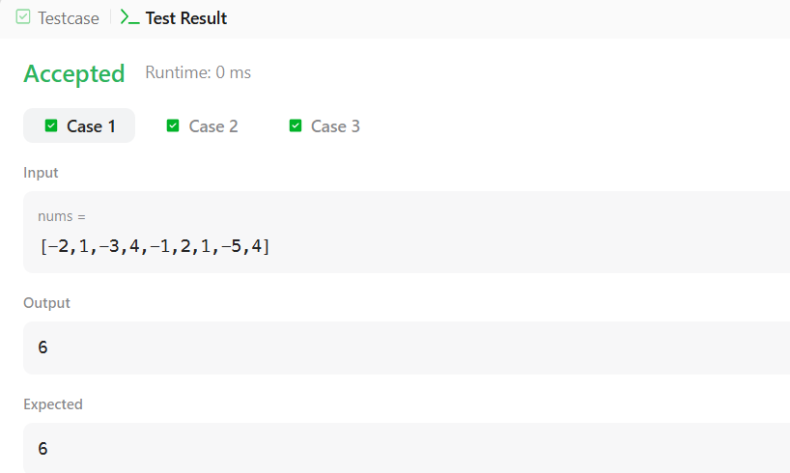

There is a biker going on a road trip. The road trip consists of n + 1 points at various altitudes. The biker starts his trip on point 0 with altitude equal 0.
You are given an integer array gain of length n where gain[i] is the net gain in altitude between points i​​​​​​ and i + 1 for all (0 <= i < n). Return the highest altitude of a point.

Example 1:
Input: gain = [-5,1,5,0,-7]
Output: 1
Explanation: The altitudes are [0,-5,-4,1,1,-6]. The highest is 1.
Example 2:
Input: gain = [-4,-3,-2,-1,4,3,2]
Output: 0
Explanation: The altitudes are [0,-4,-7,-9,-10,-6,-3,-1]. The highest is 0.

Constraints:
- n == gain.length
- 1 <= n <= 100
- -100 <= gain[i] <= 100
Program:
class Solution {
public int largestAltitude(int[] gain) {
int n = gain.length;
int mx = 0;

for (int i = 0; i <= n; i++) {
int alt = 0;
for (int j = 0; j < i; j++) {
alt += gain[j];
}
mx = Math.max(mx, alt);
}

return mx;
}
}
Output:
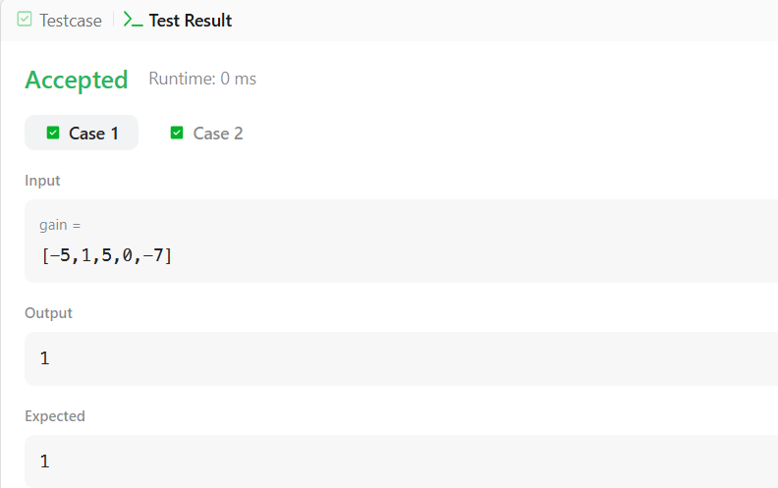
Given an array of strings strs, group the anagrams together. You can return the answer in any order.

Example 1:
Input: strs = ["eat","tea","tan","ate","nat","bat"]
Output: [["bat"],["nat","tan"],["ate","eat","tea"]]
Explanation:
- There is no string in strs that can be rearranged to form "bat".
- The strings "nat" and "tan" are anagrams as they can be rearranged to form each other.
- The strings "ate", "eat", and "tea" are anagrams as they can be rearranged to form each other.
Example 2:
Input: strs = [""]
Output: [[""]]
Example 3:
Input: strs = ["a"]
Output: [["a"]]

Constraints:
- 1 <= strs.length <= 10⁴
- 0 <= strs[i].length <= 100
- strs[i] consists of lowercase English letters.
Program:
class Solution {
public List<List<String>> groupAnagrams(String[] strs) {
Map<String, List<String>> ans = new HashMap<>();

for (String s : strs) {
char[] chars = s.toCharArray();
Arrays.sort(chars);
String key = new String(chars);
if (!ans.containsKey(key)) {
ans.put(key, new ArrayList<>());
}
ans.get(key).add(s);
}

return new ArrayList<>(ans.values());
}
}
Output:
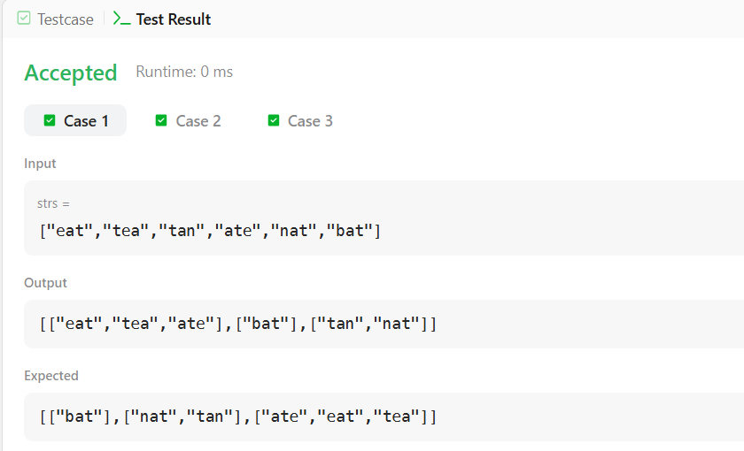

Given an integer array nums and an integer k, return the k most frequent elements. You may return the answer in any order.

Example 1:
Input: nums = [1,1,1,2,2,3], k = 2
Output: [1,2]
Example 2:
Input: nums = [1], k = 1
Output: [1]
Example 3:
Input: nums = [1,2,1,2,1,2,3,1,3,2], k = 2
Output: [1,2]

Constraints:
- 1 <= nums.length <= 10⁵
- -10⁴ <= nums[i] <= 10⁴
- k is in the range [1, the number of unique elements in the array].
- It is guaranteed that the answer is unique.
Program:
class Solution {

public int[] topKFrequent(int[] nums, int k) {

int n = nums.length;

// Step 1: Count frequency of each number
HashMap<Integer, Integer> map = new HashMap<>();

for (int num : nums) {
map.put(num, map.getOrDefault(num, 0) + 1);
}

// bucket[i] stores numbers having frequency i
List<Integer>[] bucket = new ArrayList[n + 1];

// Step 2: Place numbers into their frequency bucket
for (int key : map.keySet()) {

int freq = map.get(key);

// Create list if bucket is empty
if (bucket[freq] == null) {
bucket[freq] = new ArrayList<>();
}

// Add number into its frequency bucket
bucket[freq].add(key);
}

int[] ans = new int[k];
int index = 0;

// Step 3: Traverse from highest frequency bucket
for (int i = bucket.length - 1; i >= 0 && index < k; i--) {

// Skip empty buckets
if (bucket[i] != null) {

// Take all numbers from current bucket
for (int num : bucket[i]) {

ans[index++] = num;

// Stop once k elements are collected
if (index == k)
break;
}
}
}

return ans;
}
}
Output:
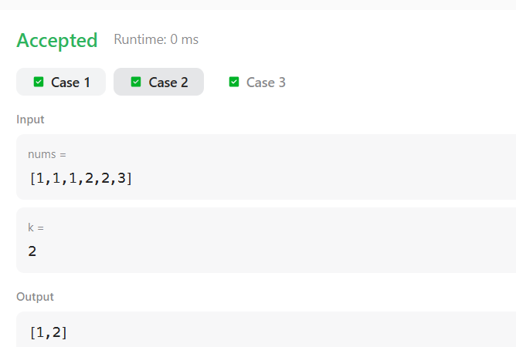
In computer science, a double-ended queue (dequeue, often abbreviated to deque, pronounced deck) is an abstract data type that generalizes a queue, for which elements can be added to or removed from either the front (head) or back (tail).
Deque interfaces can be implemented using various types of collections such as LinkedList or ArrayDeque classes. For example, deque can be declared as:
Deque deque = new LinkedList<>();
or
Deque deque = new ArrayDeque<>();
You can find more details about Deque here.
In this problem, you are given integers. You need to find the maximum number of unique integers among all the possible contiguous subarrays of size .
Note: Time limit is second for this problem.
Input Format
The first line of input contains two integers and : representing the total number of integers and the size of the subarray, respectively. The next line contains space separated integers.
Constraints
The numbers in the array will range between .
Output Format
Print the maximum number of unique integers among all possible contiguous subarrays of size .
Sample Input
6 3
5 3 5 2 3 2
Sample Output
3
Program:
import java.util.*;

public class Solution {
public static void main(String[] args) {
Scanner sc = new Scanner(System.in);

int n = sc.nextInt();
int m = sc.nextInt();

int[] arr = new int[n];

for (int i = 0; i < n; i++) {
arr[i] = sc.nextInt();
}

Deque<Integer> deque = new ArrayDeque<>();
HashSet<Integer> set = new HashSet<>();

int maxUnique = 0;

for (int i = 0; i < n; i++) {

deque.addLast(arr[i]);
set.add(arr[i]);

// When window size becomes m
if (deque.size() == m) {
maxUnique = Math.max(maxUnique, set.size());

// Remove the first element
int removed = deque.removeFirst();

// Remove from set only if it doesn't exist elsewhere
if (!deque.contains(removed)) {
set.remove(removed);
}
}
}

System.out.println(maxUnique);
sc.close();
}
}
Output:
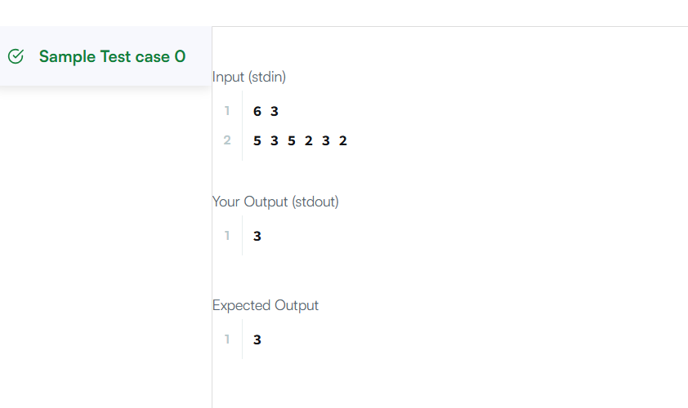

In computer science, a set is an abstract data type that can store certain values, without any particular order, and no repeated values(Wikipedia). is an example of a set, but is not a set. Today you will learn how to use sets in java by solving this problem.
You are given pairs of strings. Two pairs and are identical if and . That also implies is not same as . After taking each pair as input, you need to print number of unique pairs you currently have.
Complete the code in the editor to solve this problem.
Input Format
In the first line, there will be an integer denoting number of pairs. Each of the next lines will contain two strings seperated by a single space.
Constraints:

- Length of each string is atmost and will consist lower case letters only.
Output Format
Print lines. In the line, print number of unique pairs you have after taking pair as input.
Sample Input
5
john tom
john mary
john tom
mary anna
mary anna
Sample Output
1
2
2
3
3
Program:
import java.util.HashSet;
import java.util.Scanner;

public class Solution {
public static void main(String[] args) {

Scanner sc = new Scanner(System.in);

int n = sc.nextInt();

HashSet<String> set = new HashSet<String>();

for (int i = 0; i < n; i++) {
String a = sc.next();
String b = sc.next();

set.add(a + " " + b);

System.out.println(set.size());
}

sc.close();
}
}
Output:

